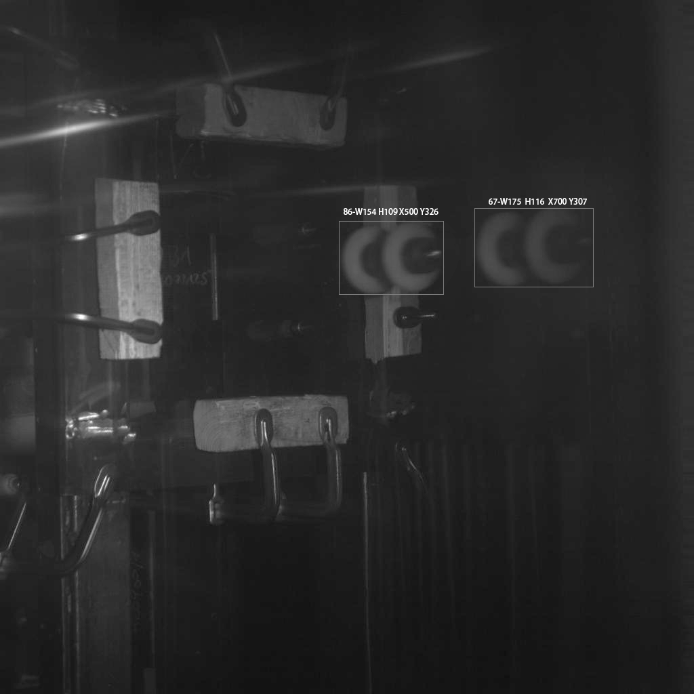

X1 – X2 = 200 pixel

86: 157 piexl = 167mm

67: 175 piexl = 167mm

Maßstab = (157+175)/2/167 =1 piexl/mm

S = 200 \* 1 = 200mm

t = (86 -67 )/5400fps

v = s/t